Lab

Use a minikube built-in command to call the web-cli service and view the nginx webpage
minikube service web-cli
🎉 Opening service default/web-cli in default browser...
👉 http://127.0.0.1:37245
❗ Because you are using a Docker driver on linux, the terminal needs to be open to run it.

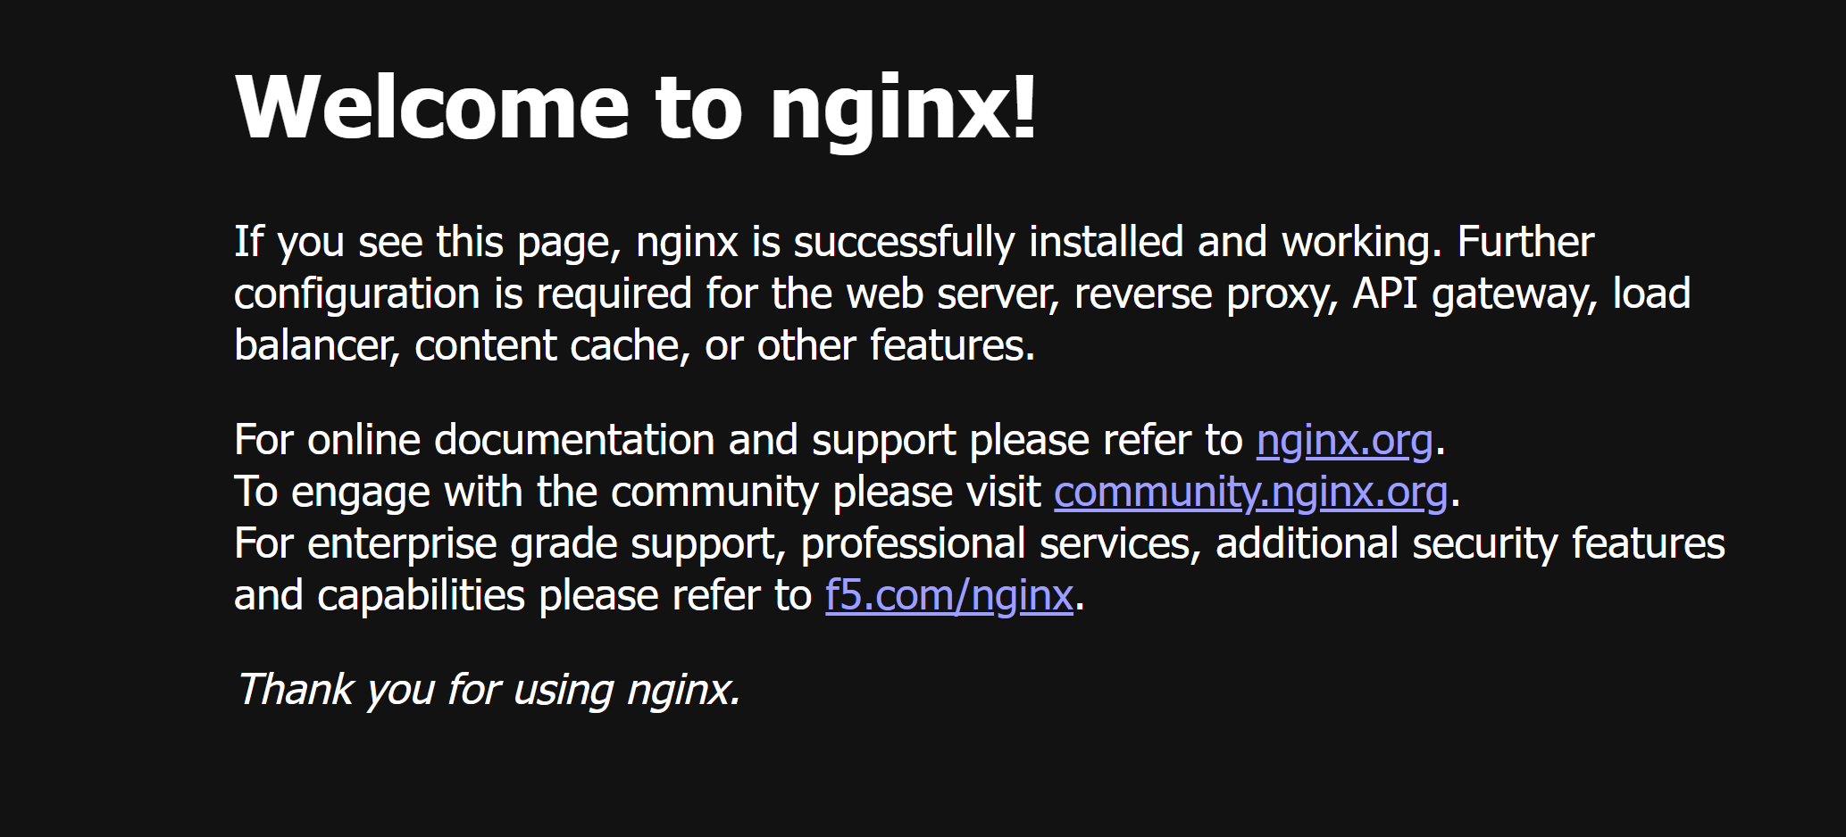

Load balancing with NodePort service
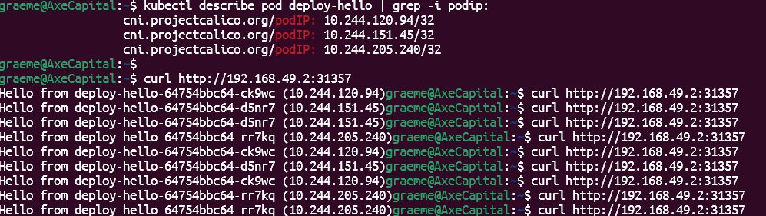

Delete a pod web-cli-86895cb6-tl28d (by ‘mistake’):

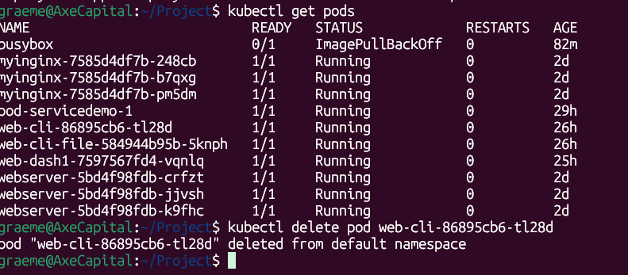
But the cluster restarts the pod again as web-cli-86895cb6-vd9q8:
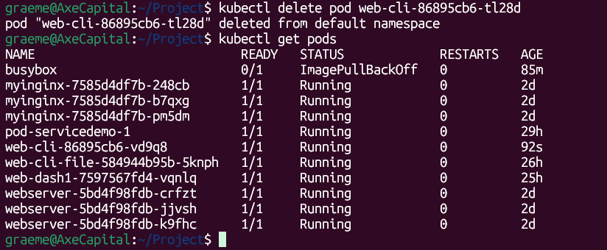

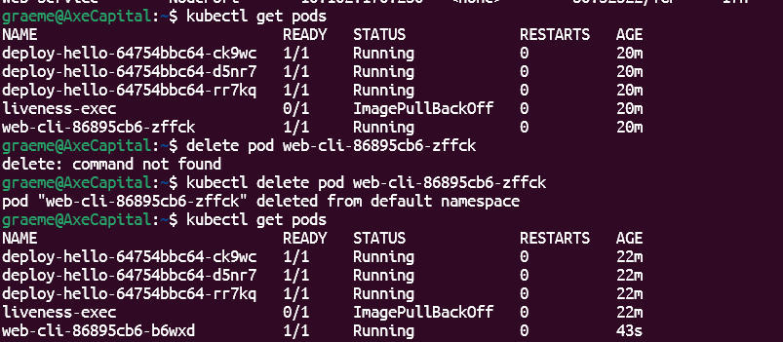
Terraform install and re-run result

